Project Design Phase-II
Data Flow Diagram & User Stories

Date | 07 march 2026
Team ID | SWTID-2026-6943
Project Name | Project inventory management
Maximum Marks | 4 Marks

Data Flow Diagrams:
A Data Flow Diagram (DFD) is a powerful and widely used visual tool that represents the flow of information within a system in a clear and structured way. It provides a graphical view of how data moves through different processes, making complex system requirements easier to understand and analyze. A well-designed and neatly organized DFD can effectively illustrate the entire structure of a system by showing how data enters the system, how it is processed or transformed by different components, and how it finally exits the system.
Additionally, a DFD highlights the locations where data is stored and explains how various processes, data stores, and external entities interact with each other. By presenting these interactions visually, a Data Flow Diagram helps developers, analysts, and stakeholders gain a better understanding of the system’s functionality and data movement.

User Type | User Story Number | User Story / Task | Acceptance Criteria | Priority | Release
Customer (Web User) | USN-1 | As a user, I can register and log in securely using JWT authentication | User can create account and receive token after login for the program process | High | Sprint-1
Customer (Web User) | USN-2 | As a user, I can add new products to my inventory process | Product is saved and visible only to logged-in user | High | Sprint-1
Customer (Web User) | USN-3 | As a user, I can view all my products in a dashboard of the program | Products load successfully with valid token of the product | High | Sprint-1
Customer (Web User) | USN-4 | As a user, I can update product details like price and quantity checking process | Changes are saved and reflected instantly for the purpose of executing | Medium | Sprint-2
Customer (Web User) | USN-5 | As a user, I can delete products from my inventory process | Product disappears from dashboard after deletion | Medium | Sprint-2
Customer (Web User) | USN-6 | As a user, I can search products by name for the pupose of purchasing | Filtered results appear based on keyword | Low | Sprint-2

User Stories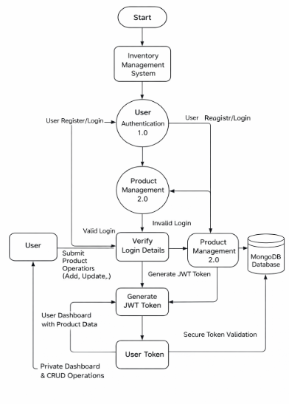
Use the below template to list all the user stories for the product.
Key Features of Data Flow Diagram (DFD)
• Provides a clear graphical representation of data movement within a system.
• Shows how data enters, is processed, stored, and exits the system.
• Helps in understanding complex system processes easily.
• Identifies interactions between processes, data stores, and external entities.
• Improves communication between developers, analysts, and stakeholders during system development.
Conclusion
In conclusion, a Data Flow Diagram (DFD) plays an important role in understanding how information moves within a system. It visually represents the flow, processing, and storage of data in a clear and organized manner. By simplifying complex system operations into graphical elements, a DFD helps developers, analysts, and stakeholders better understand system functionality and improves the design and development process.

